**Sliding Mode Control of Rotary Inverted Pendulum**

Akshay Khadse

Roll No. 153079011

1. **Problem Description**

Design a nonlinear controller for upright balancing of Rotary Inverted Pendulum System.

**Model Parameters:**

1. Length of Pendulum $(L)$ = 0.153 m
2. Length of Arm $(r)$ = 0.08260 m
3. Equivalent Inertia of Arm and Motor = Kg m2
4. Inertia of Pendulum = Kg m2
5. Viscous Damping Coefficient at motor shaft Joint ${(B}_{eq})$ = 0.0015 Nm/(rad/sec)
6. Viscous Damping Coefficient at Pendulum Arm Joint ${(B}_{pen})$ = 0.0005 Nm/(rad/sec).

Provided model takes torque as input and has two angles as output. So, a suitable motor needs to be considered while modelling as motor parameters are not provided. Let the motor parameters as follows **[2]**:

1. Torque Constant ${(K}_{t})$ = 0.02797 Nm/A
2. Back EMF Constant ${(K}_{m})$ = 0.02797 V/(rad/sec)
3. Armature Resistance $(Rm)$ = 3.3 Ohm
4. Voltage Rating = 10 V

**2. Modelling:**

|  |  |  |
| --- | --- | --- |
| C:\Users\Akshay\AppData\Local\Microsoft\Windows\INetCache\Content.Word\T23-021-719_2_Page3_Image2.jpg |  | C:\Users\Akshay\AppData\Local\Microsoft\Windows\INetCache\Content.Word\T23-021-719_2_Page3_Image1.jpg |
| **Figure: Rotary Inverted Pendulum Schematics** | | |

Above figure represents arm angle and pendulum angle with their respective references.

Let the state vector be $x={\left[α \dot{α }θ \dot{θ}\right]}^{T}$

Let

$$a=J_{eq}+mr^{2}$$

$$b=mLr$$

$$c=\frac{4}{3}mL^{2}$$

$$d=mgL$$

$$G=\frac{K_{t}K_{m}+B_{eq}R_{m}}{Rm}$$

Then state equations are as follows **[1]**

$${\dot{x}}_{1}=x_{2}$$

$${\dot{x}}_{2}=f_{1}\left(x\right)+g_{1}\left(x\right)u$$

$${\dot{x}}_{3}=x_{4}$$

$${\dot{x}}_{4}=f_{2}\left(x\right)+g_{2}\left(x\right)u$$

Where

$$f_{1}\left(x\right)=\frac{\frac{-b^{2}}{2}\sin\left(2x_{1}\right)x_{2}^{2}-Gbx_{4}\cos\left(x_{1}\right)+aⅆ\sin\left(x_{1}\right)}{ac-b^{2}\cos^{2}\left(x_{1}\right)}$$

$$g_{1}\left(x\right)=\frac{K_{t}b\cos\left(x_{1}\right)}{R_{m}\left(ac-b^{2}\cos^{2}\left(x_{1}\right)\right)}$$

$$f_{2}\left(x\right)=\frac{cf_{1}\left(x\right)-ⅆ\sin\left(x_{1}\right)}{b\cos\left(x_{1}\right)}$$

$$g_{2}\left(x\right)=\frac{K_{t}c}{R_{m}\left(ac-b^{2}\cos^{2}\left(x_{1}\right)\right)}$$

1. **Sliding Mode Controller**

For pendulum angle $(α)$ to converge to zero

$${\dot{x}}_{1}+λ_{1}x_{1}=0$$

For arm angle $(θ)$ to converge to zero

$${\dot{x}}_{3}+λ_{3}x_{3}=0$$

Therefore, consider two manifolds as

$$s_{1}=x_{2}+λ_{1}x_{1}$$

$$s_{2}=x_{4}+λ_{3}x_{3}$$

Consider a Lyapunov candidate as

$$V=\left|s_{1}\left|+λ_{2}\right|s_{2}\right|$$

Then, stability can be assured if derivative of Lyapunov function is of the form

$$\dot{V}=-κ sat\left(\frac{V}{ϕ}\right)$$

where

$$sat\left(\frac{V}{ϕ}\right)=\frac{V}{ϕ} if ϕ<\left|V\right|$$

$=\operatorname{sgn}\left(V\right)$, otherwise

If input is chosen as

$$u=\frac{-κ sat\left(\frac{V}{ϕ}\right)-\left(λ_{1}x_{2}+f_{1}\left(x\right)\right)\operatorname{sgn}\left(s_{1}\right)-λ_{2}\left(λ_{3}x_{4}+f_{2}\left(x\right)\right)\operatorname{sgn}\left(s_{2}\right)}{g_{1}\left(x\right)\operatorname{sgn}\left(s_{1}\right)+g_{2}\left(x\right)\operatorname{sgn}\left(s_{2}\right)}$$

Then, derivative of Lyapunov function is $\dot{V}=-κ sat\left(\frac{V}{ϕ}\right)$

Thus, system is stable for this choice of control input.

But, this is in form of voltage. To calculate corresponding torque generated by motor following relation holds

$$T=\frac{K_{t}\left(V_{m}-K_{m}\dot{θ}\right)}{R_{m}}$$

1. **Tuning**

$κ$, $λ_{1}$, $λ_{2}$, $λ_{3}$ and $ϕ$ are the tuning parameters in this case. Following intuition was applied for tuning:

1. For both the angles to be stable $λ_{1}$ and $λ_{3}$ must be greater than zero. Higher the values of these parameters, lesser would be the respective settling times. Also, $λ_{1}$ should be much higher than $λ_{2}$ because, for upright balancing of pendulum, control of $α$ is more emphasised than that of $θ$.
2. $λ_{2}$ serves as trade off between the two manifolds, and therefore should be in between 0 and 1.
3. $κ$ is indicative of rate at which $V$ approaches 0. So, this cannot be less than zero.

Using this intuition, suitable values of these parameters turned out to be

$$κ=2$$

$$λ_{1}=0.2$$

$$λ_{2}=0.01$$

$$λ_{3}=5$$

$$ϕ=0.5$$

1. **Results**

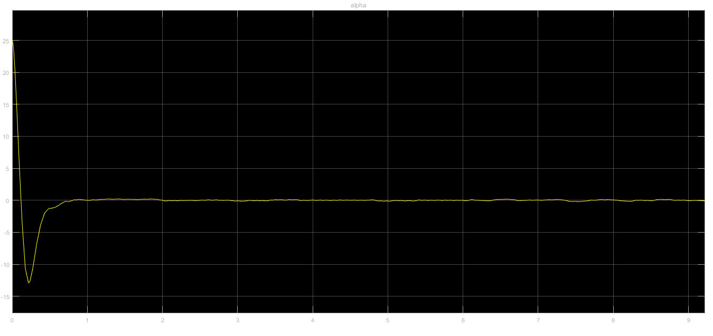

**Figure 1:Variation of alpha for initial disturbance of 25 degrees**

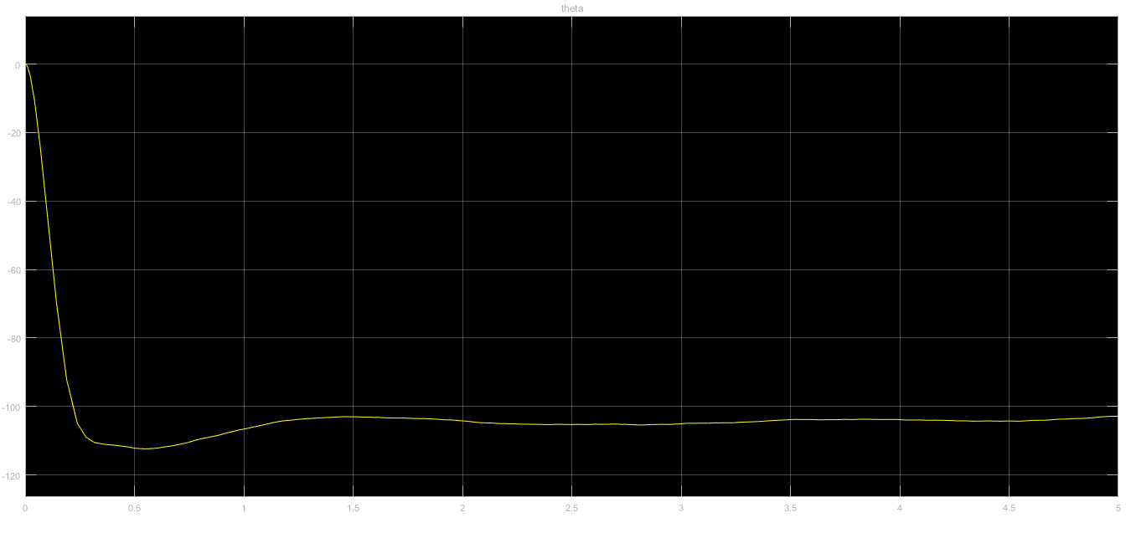

**Figure 2: Variation of theta for initial disturbance of 25 degrees**

Pendulum was disturbed initially by 25 degrees. Following are observations for this initial disturbance

Settling time of alpha = 1 sec (approx.)

Settling time of theta = 3 sec (approx)

1. **Conclusions:**
2. A nonlinear sliding mode controller was designed for rotary inverted pendulum system provided.
3. Controller can stabilize initial pendulum angle disturbances up to 25 degrees.
4. For larger disturbances, up to 30 degrees, some performance starts degrading.

**References:**

1. Sliding Mode Control of Rotary Inverted Pendulm, M. A. Khanesar, M. Teshnehlab, M. A. Shoorehdeli, Proceedings of the 15th Mediterranean Conference on Control & Automation, 2007
2. QNET Experiment #04: Inverted Pendulum Control reference manual, Pages [5-6]